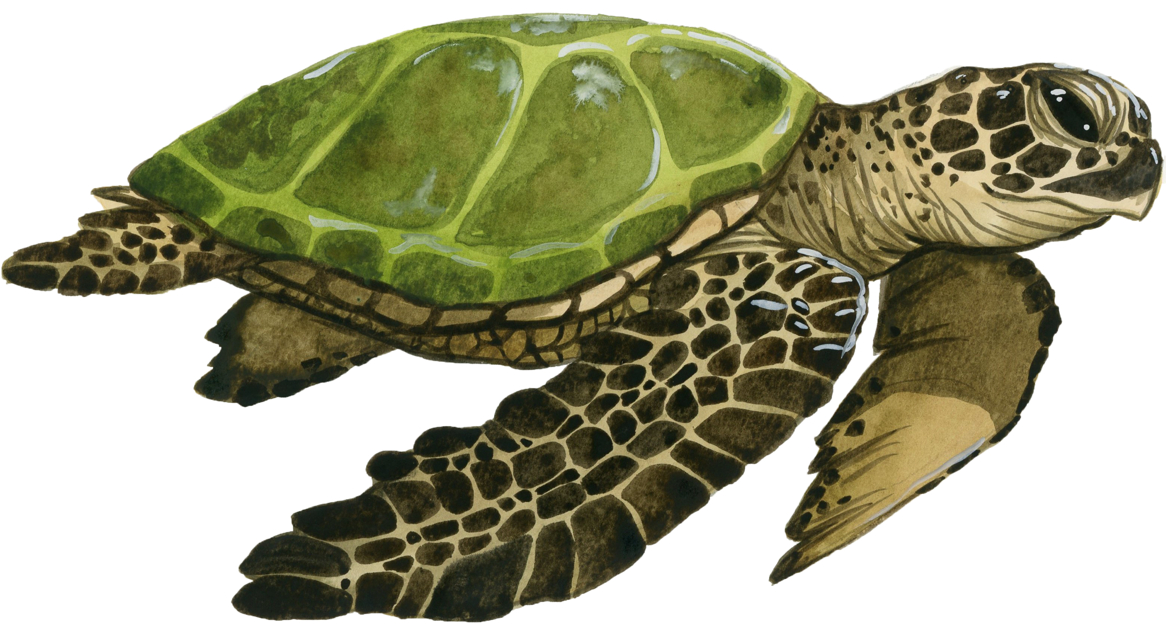
Sea Turtle Tracker

by Rebecca Tripp and Tom McConnell
www.conservationtales.com/sea-turtles
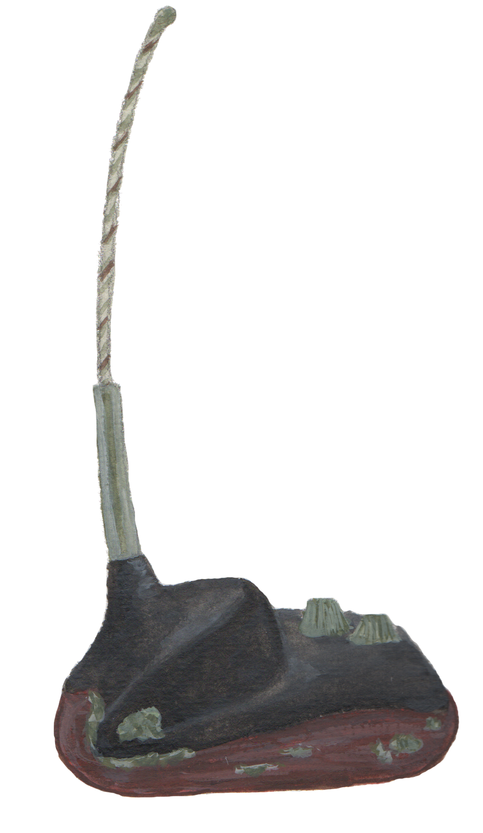
GPS transmitter
Instructions
- Go to My Wildlife Computer’s website to view the map. On the right side of the screen, you will see a list of “Deployments.” These are turtles with tracking data you can view. Select a few of the turtles that are listed under Deployments.
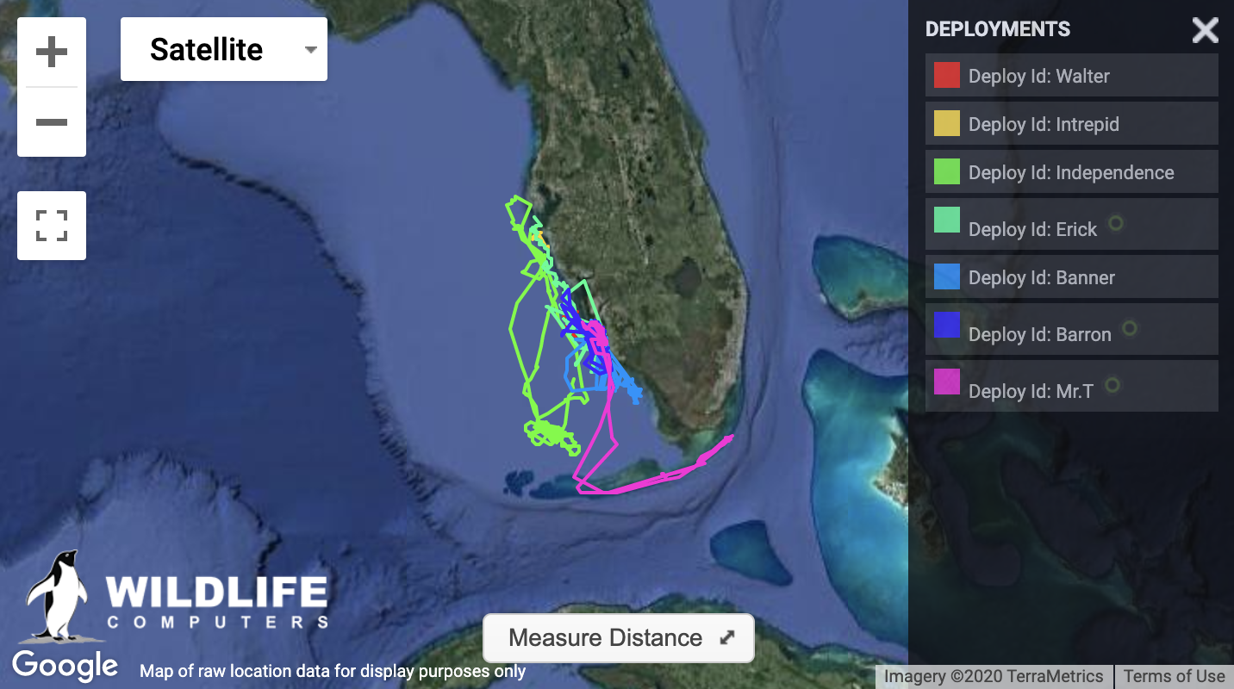
- In the table below, write the names of the turtles you selected.
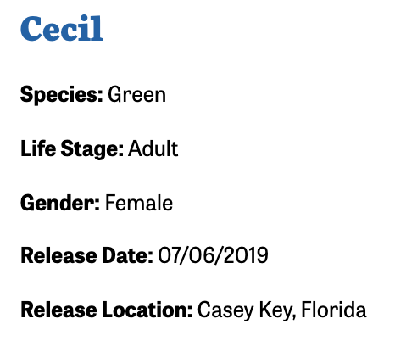
- Visit Mote’s Sea Turtle Tracking page. Scroll down the page to find out more about your selected turtles, and take notes in the table the gender of the turtle and its release date.

- Now think of a question you can answer using the data you can find in the map. Here are some examples, but you can come up with your own:
  - “Do male turtles travel farther than females?”
  - “Which species of sea turtle travels farther.”

- Now return to the map, and click on the names of one of the turtles on your list. Record some information about the distances traveled, how close they stayed to land, what seems to be the farthest segment they traveled, etc. When viewing the map, you can select “Satellite” view or “Map” view. Each may give you different information.
- Use the data you record to look for patterns and answers to your research question.

- Research Question: Write the question you want to investigate in the space below:

- Sea Turtle Tracking Data Table

Name | Gender | Release Date | Notes about data on map | “I wonder about…”

- Analysis: What patterns do you see in the data you recorded? What differences do you notice?

- Inferences: Try to answer the research question at the top of the page.

- New Questions? Write any new questions you have after looking at the data.

Reflections

- What information would like to have to help you answer your research question, but you didn’t have access to it?
- Were there any surprises you found in the data? What did you find out that you did not expect?
- Are there any reasons scientists might not share ALL the data they have about sea turtles?

- How do you think the process you did in your investigation compares to what a real sea turtle researcher might do with this data?

